1. 
2. 
3. 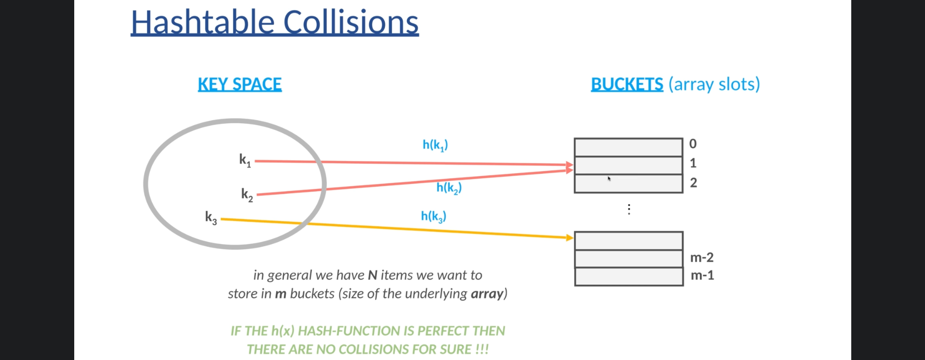
4. 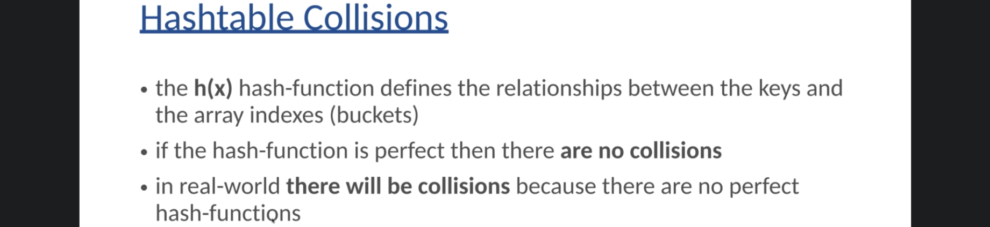
5. 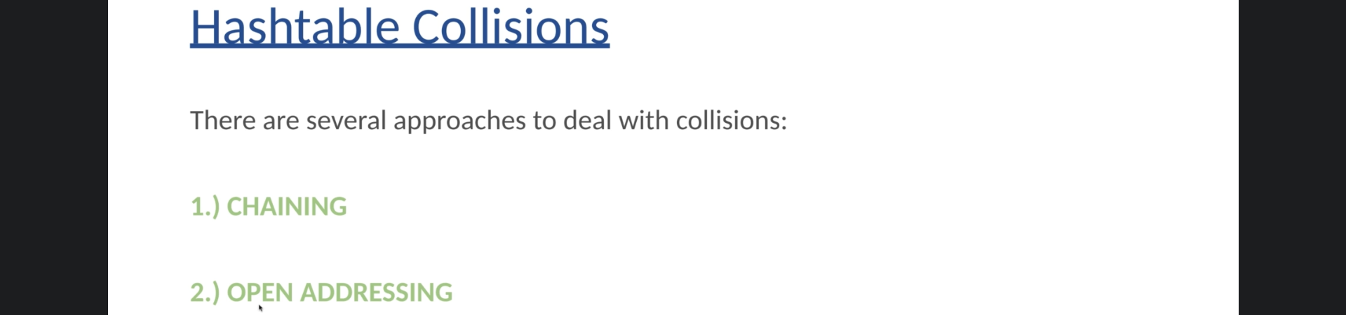
6. 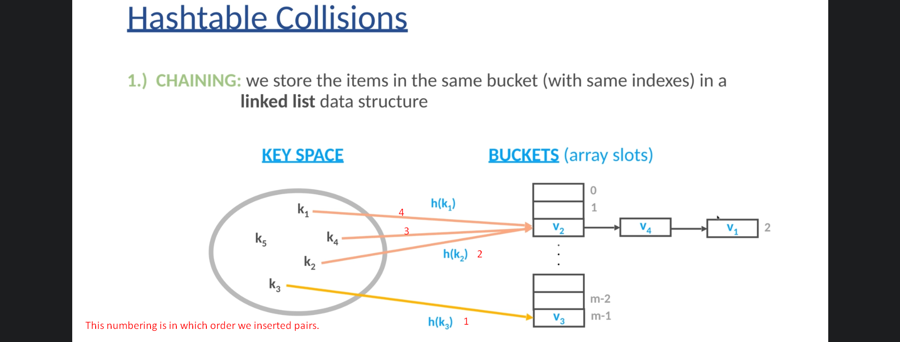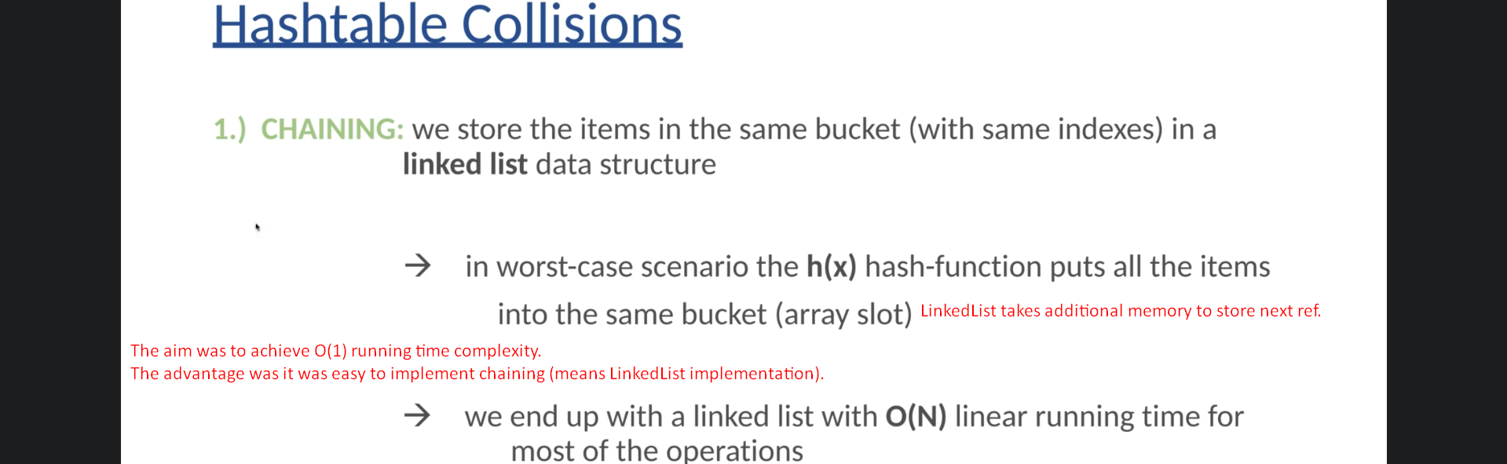
7. **Open Addressing**:   
   
   1. There are several ways to implement “Open Addressing”. The first one is called **Linear Probing**.
8. **Linear Probing**:
   1. 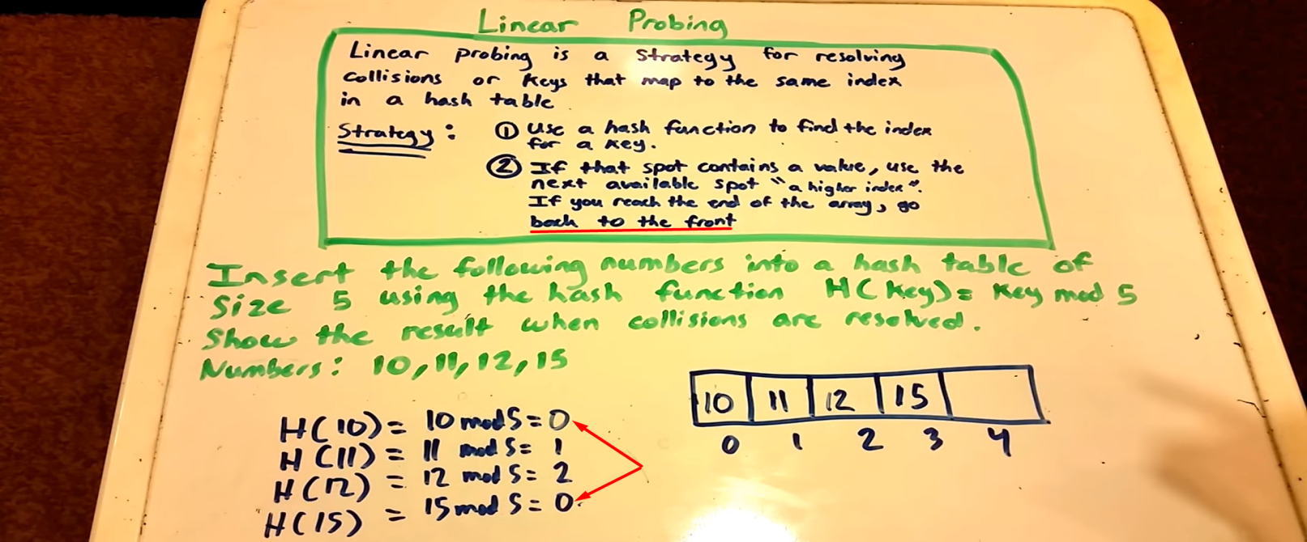
   2. 
9. **Quadratic Probing**:
   1. 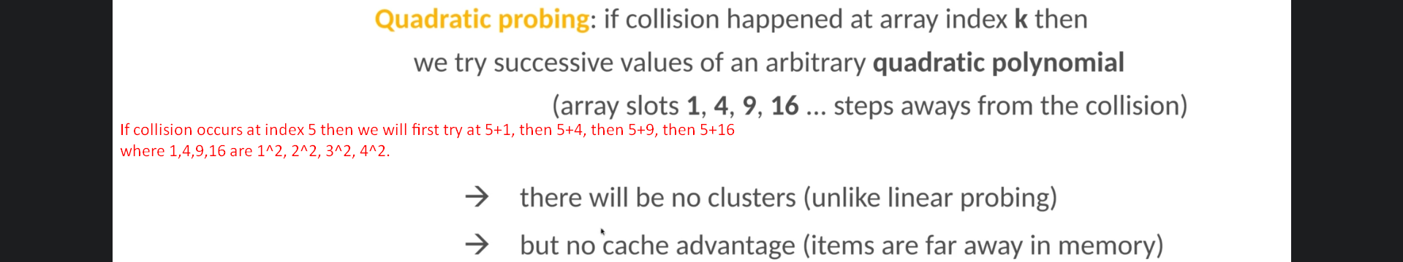
10. Rehashing:
    1. 
11. Open Addressing is difficult to implement from the scratch so better to use chaining.
12. Let’s see Linear Probing.
13. 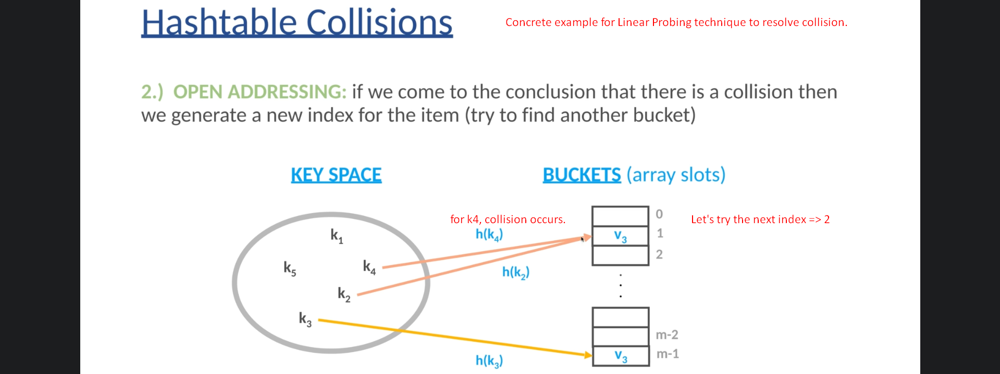
14. 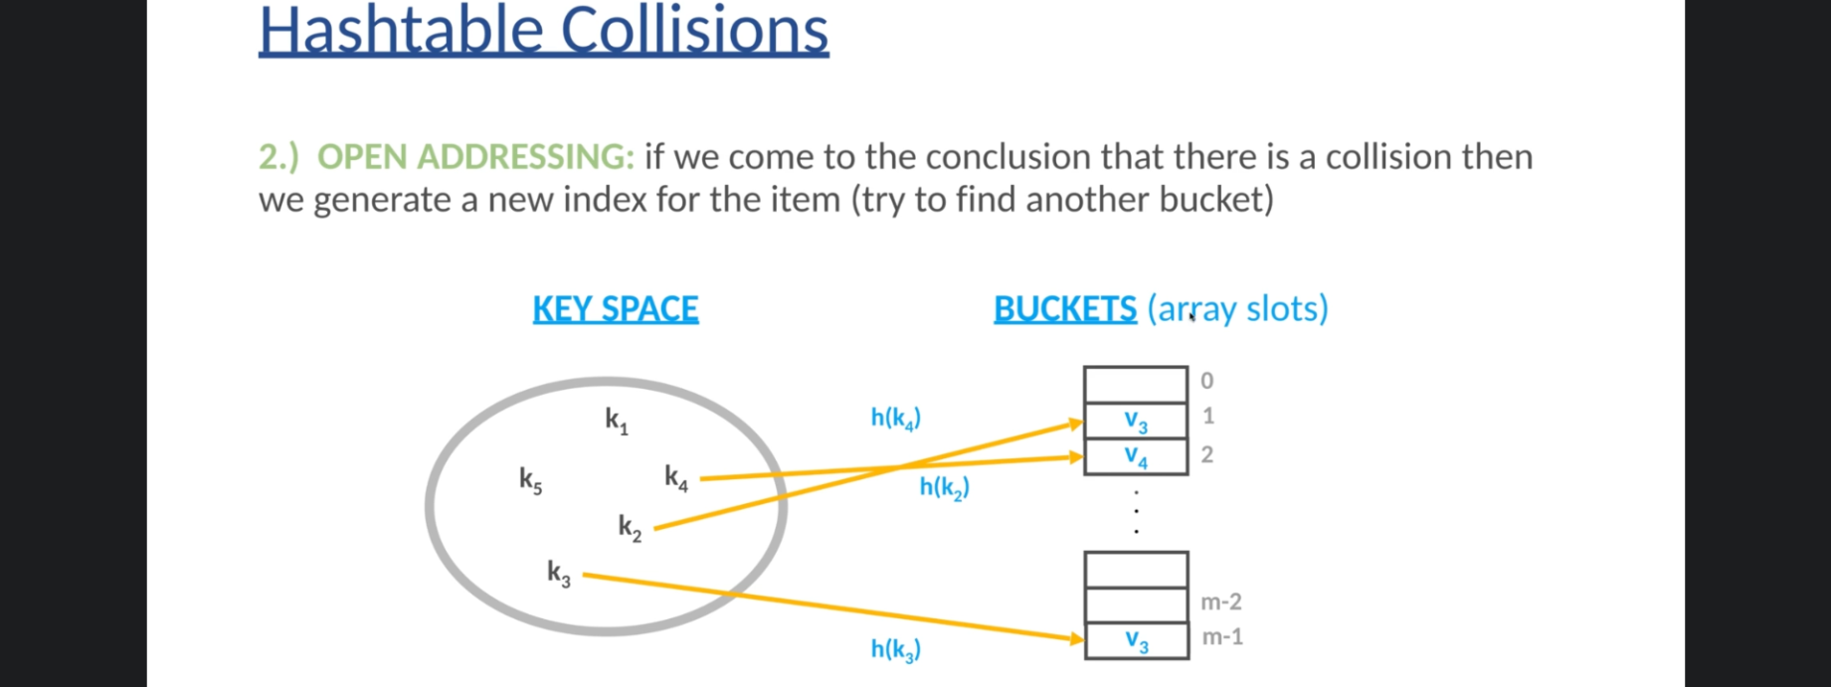
15. 